Lab 5 : docker Logging

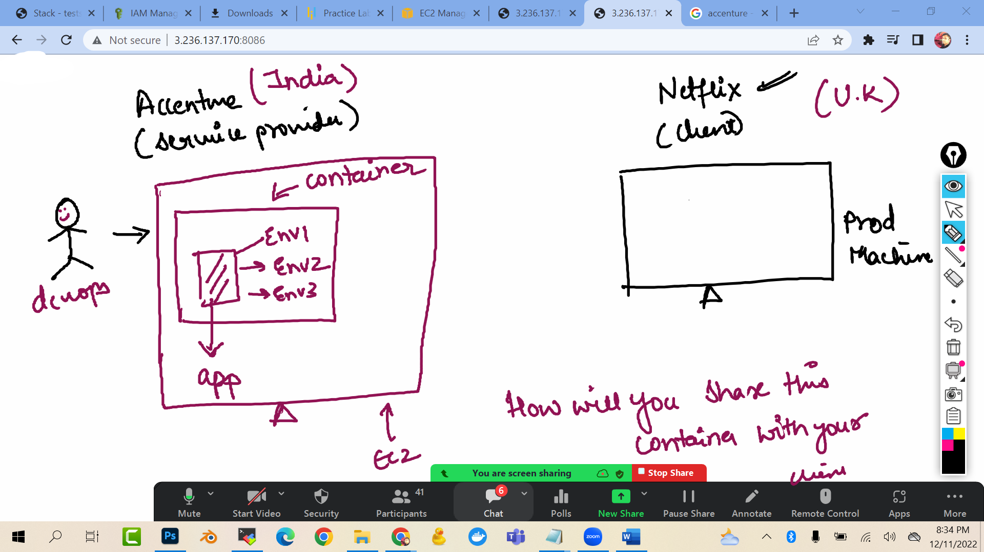

Problem statement: Lets say you are working for Accenture where you have deployed the app inside the container. Now your client is Netflix who is in other country and using different prod machine.   
How will you deploy the Container in your client server?

Solution: So I will create a custom image of the container (which will contain the app and all the dependencies as read only template) and I will put it some common repository from where my client can pull that custom image into his/her production machine. That common repository we can create in Dockerhub.com

**LAB:**

1. Create a container and inside the container create some files

docker run -it --name c07 ubuntu /bin/bash

touch file1 file2 file3 file4

apt update -y

apt install apache 2 (you can install anything …this is for demo only)

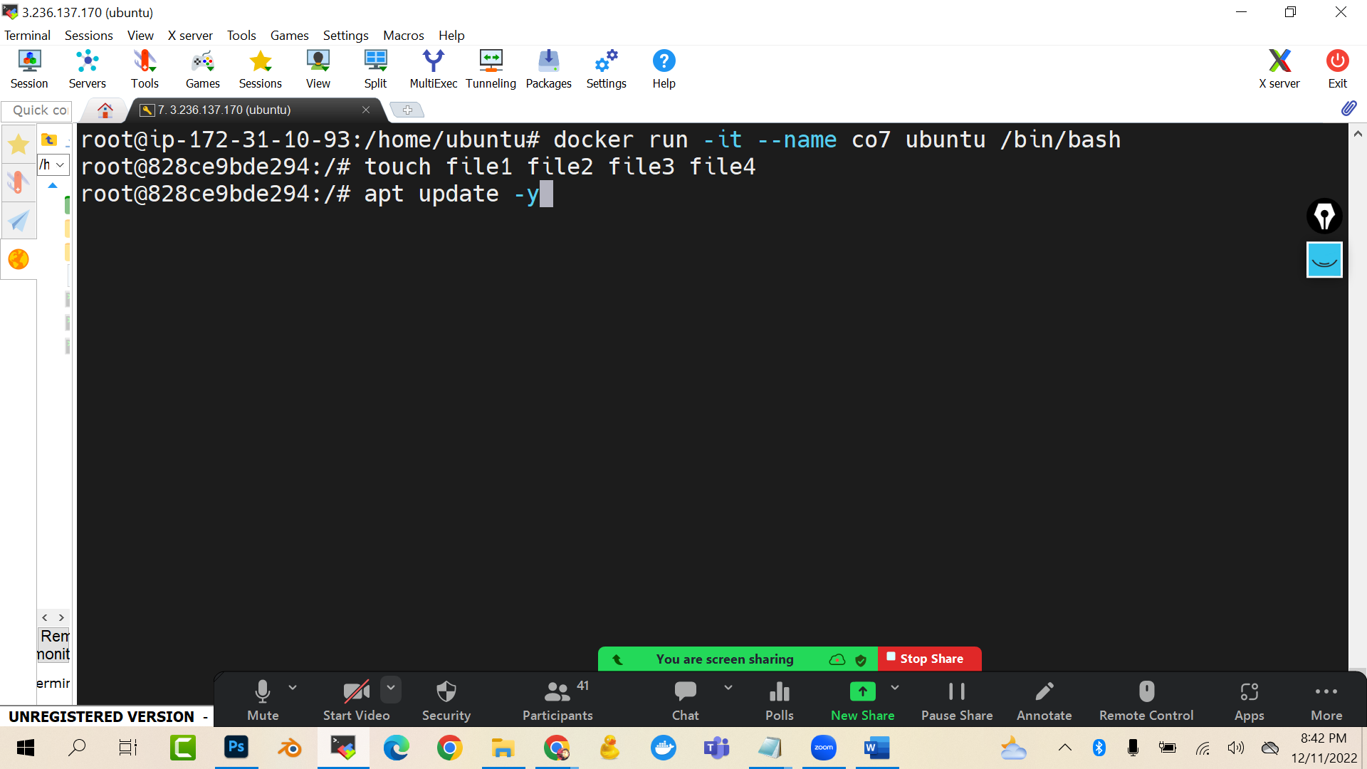

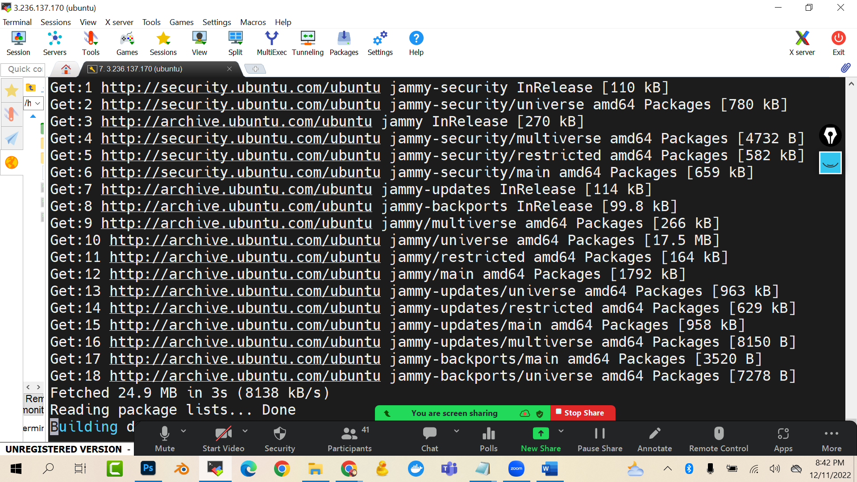

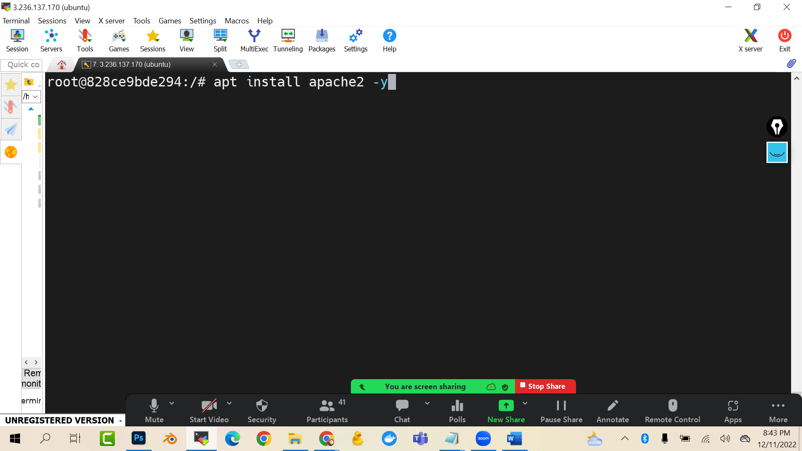

exit

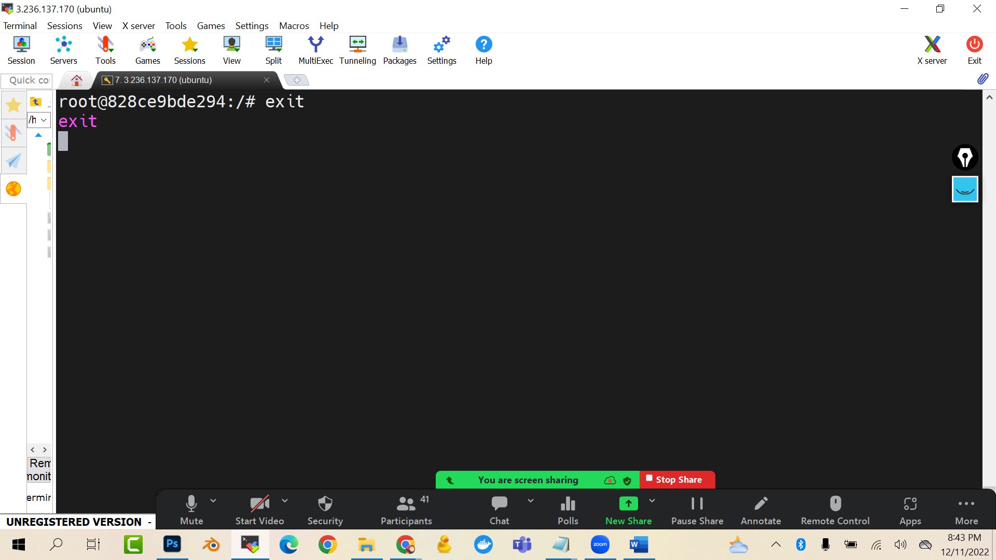

docker commit co7 projimage

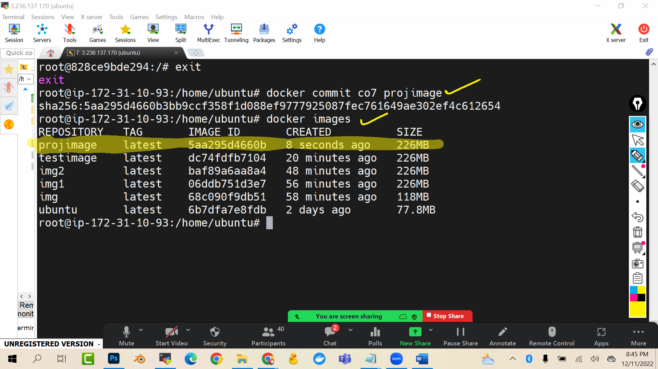

Now go to Dockerhub.com -> login

(The login credentials you have to use here as well)

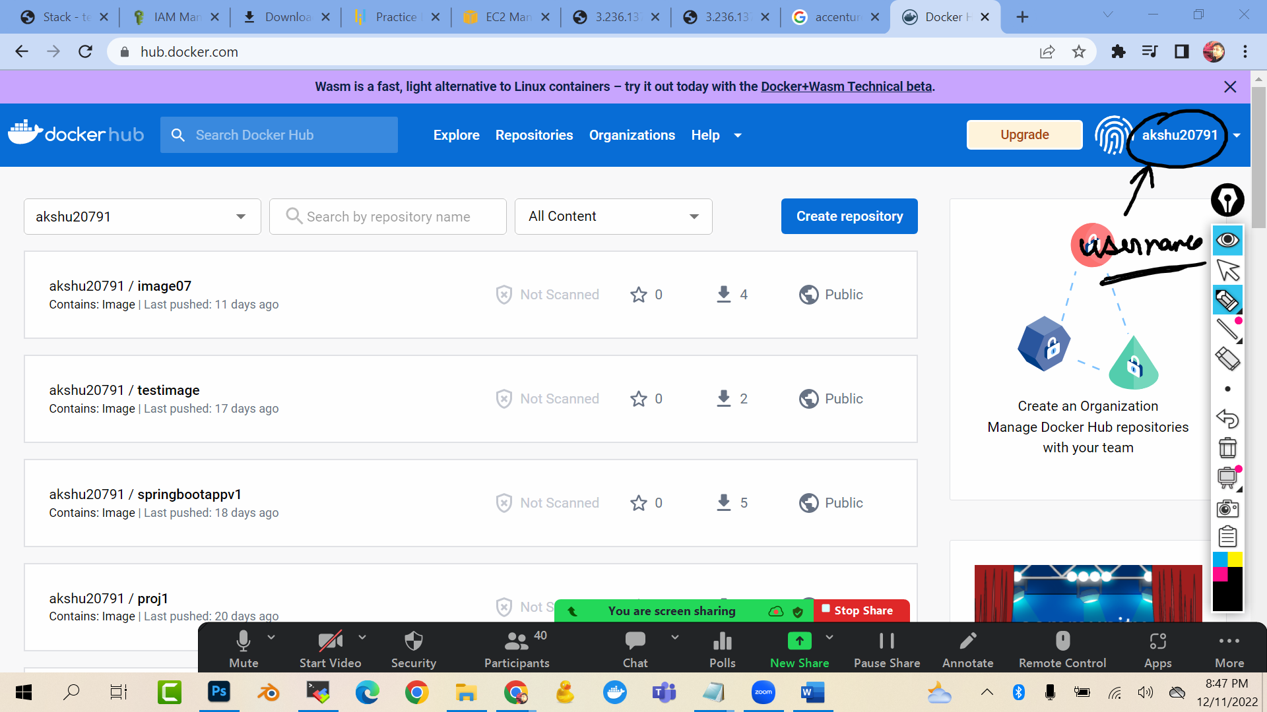

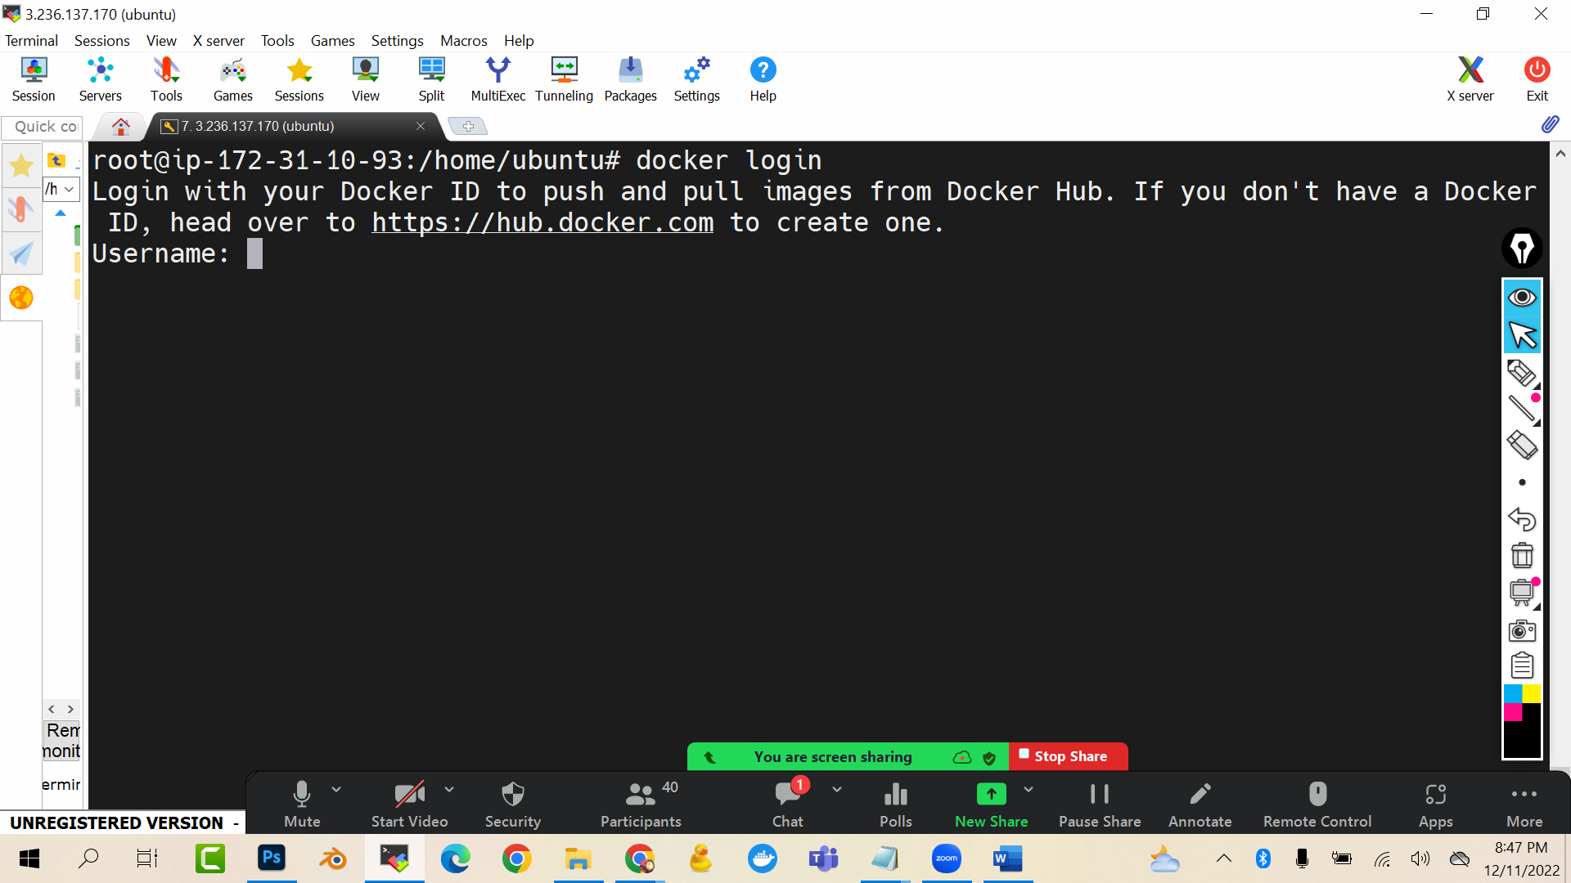

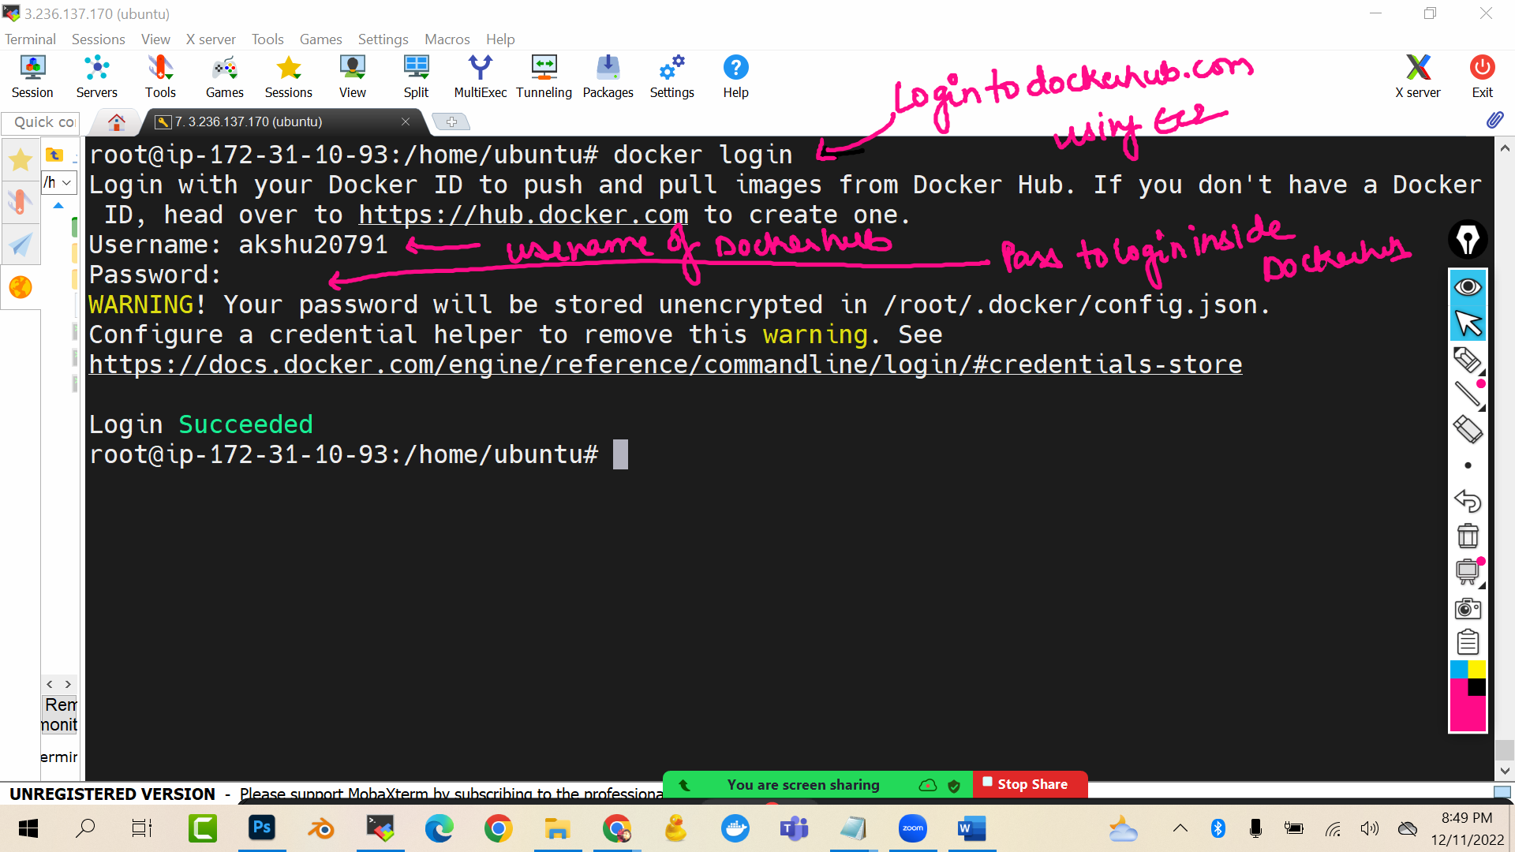

(USE YOUR USERNAME NOT MINEEEEEEE)

NOW we need to the tag the image with the username(use your username )

docker tag projimage akshu20791/projimage

(akshu20791 should be replaced with your dockerhub.com login username)

(It will create a new image akshu20791/projimage which is replica of projimage with same image id)

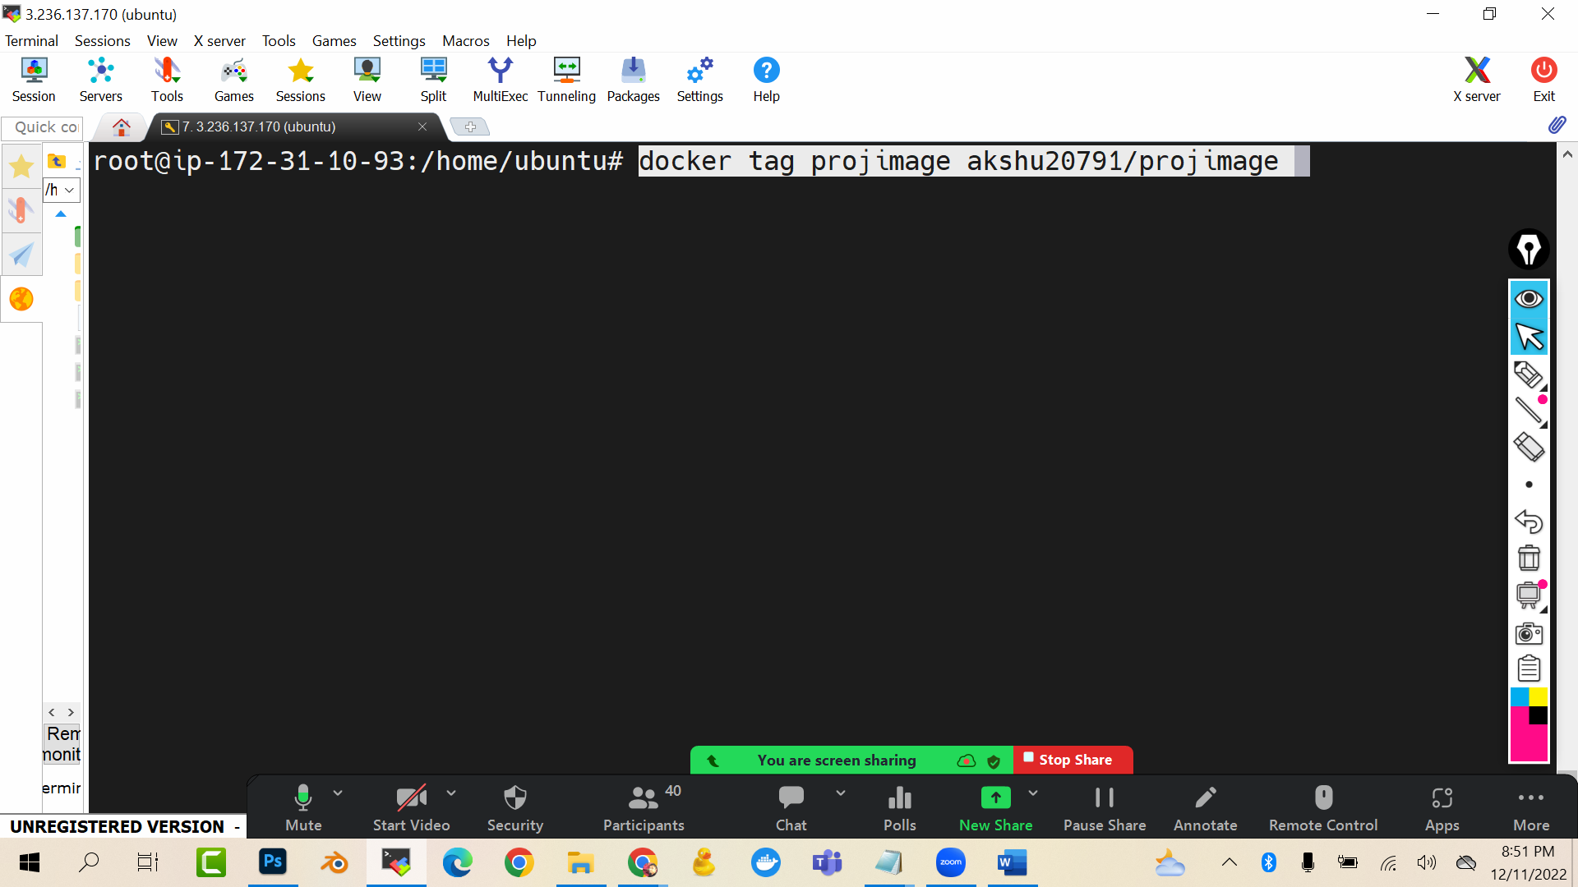

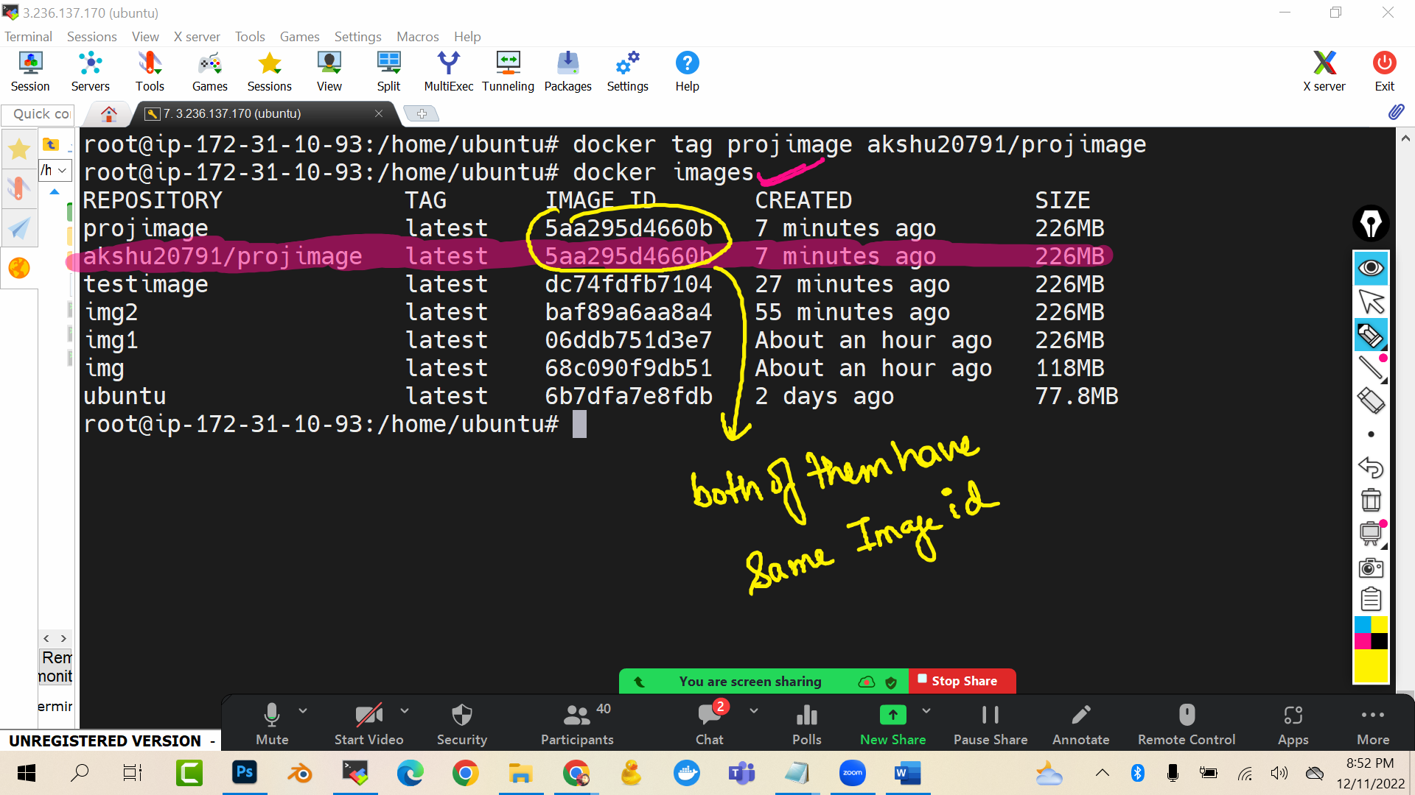

docker push akshu20791/projimage

(remember : akshu20791 is Akshat dockerhub login…you have to use yours)

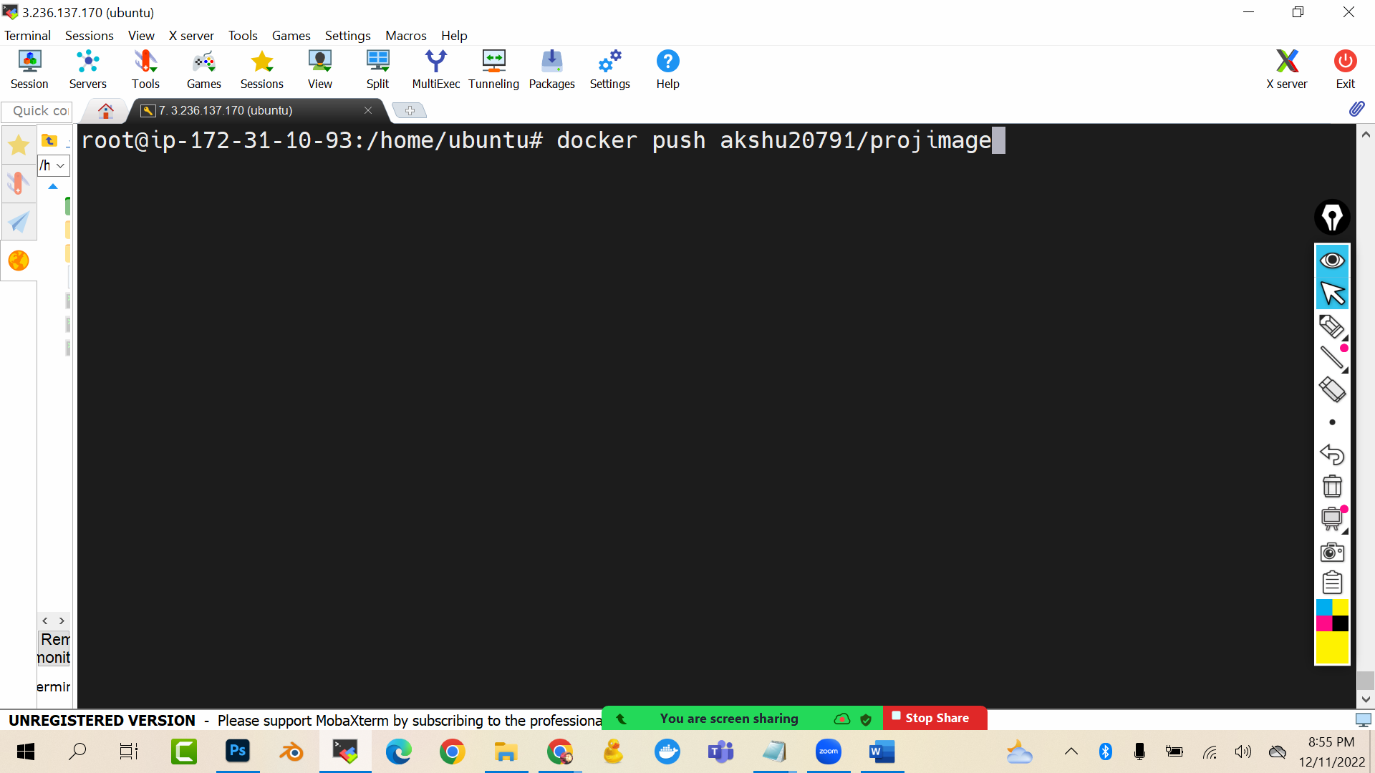

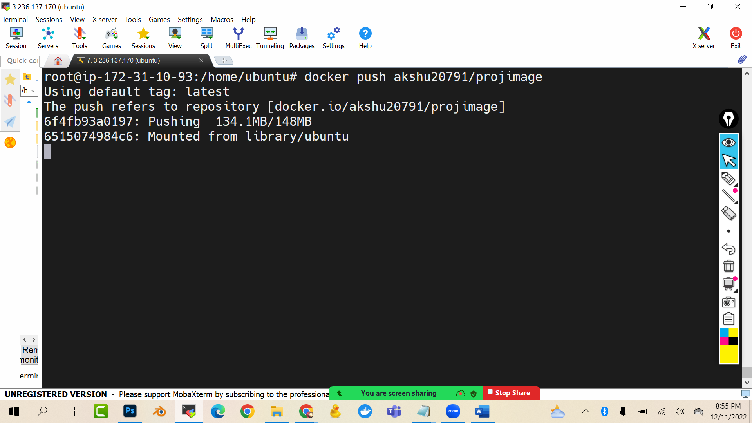

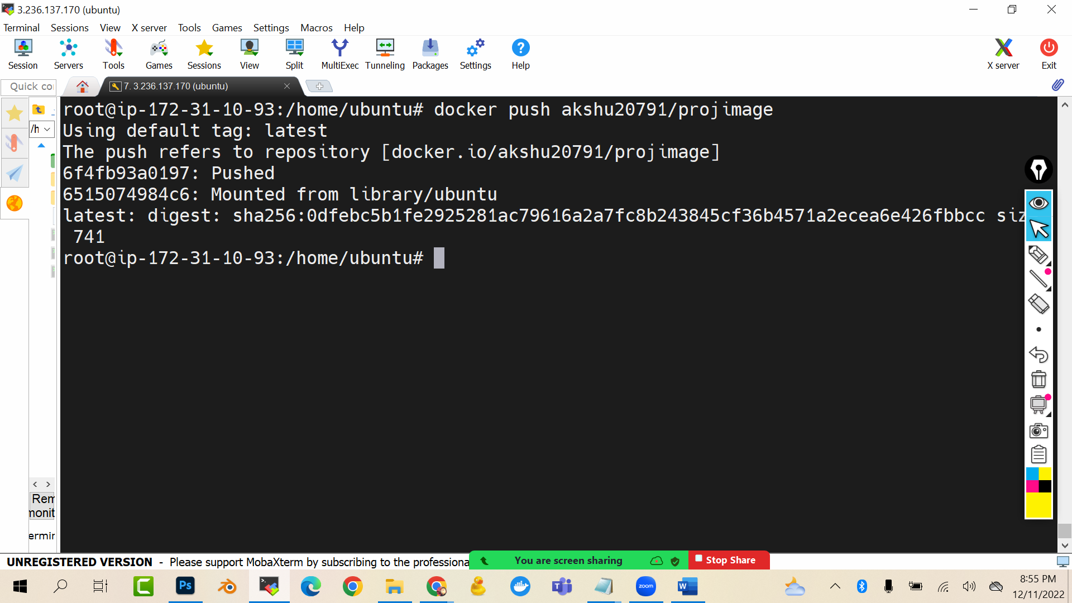

Now go to dockerhub.com and login and check repositories

